**Curriculum Vitae**

**Translator &Education Trainer and Consultant**

|  |  |
| --- | --- |
| **C:\Users\A\Desktop\Ebrahim Asal Photo.jpg** | **Ebrahim Mohammed Ahmed Asal**  **Education Specialist ,Consultant , Trainer& Teacher of English**  **Royal Commission for Training & consulting for Yanbu and Jubail**  **Riyadh, KSA**  **-----------------------------------------**  **Mobiles : (973) 34353382**  **e-mail :** [**tarjama@live.com**](mailto:tarjama@live.com) |

**NO of Experience : 42 years Since 1975 to Sept.2017)**

**----------------------------------------------------------------------------------**

**Experience :(42 years from 1975 until September 2017 .**

(01) An Education Specialist & instructor. Ministry of Education.Bahrain 2017

(02) Education Trainer . Royal commission for Yanbu &Jubail, K.S.A.2017

(03) Education Consultant for Royal Commission for Yanbu & Jubail KSA .2015

(04)Teacher and Lecturer of English at (KAPAARC) Riyadh .K,S,A,

(05)Teacher and Lecturer of English at (KFCRIS) Riyadh .K.S.A

(06)Teacher of English at Muharraq Secondary School .Bahrain .

(07) Teacher of English at Ahmed Al Omran Secondary School .Bahrain.

(08) Teacher of English at Sh. Isa Ben Ali Secondary School .Bahrain .

(09) Teacher of English at Sh.Abdullah Ben Isa Al Khalifa School .Bahrain

(10)Lecturer of English .Zagazig Technical institute ,Egypt .1989

(11) Lecturer of English .Faculty of Commerce .Zagazig University.Egypt.1988

(12)Teacher & Lecturer of English .Yemeni Armed Forces .Yemen 1987

(13) Senior Teacher of English at Naser Second girls School .Zagazig .Egypt .

(14) Teacher of English at Belbeis Secondary Military School.Egypt .

(15) Teacher of English at Zagazig Secondary Military School .Zagazig Egypt .

(16) Teacher of English at Abu Hammad Second.industrial School .Egypt .

(17) Teacher of English at Burdein Middle School .Zagazig .Egypt .

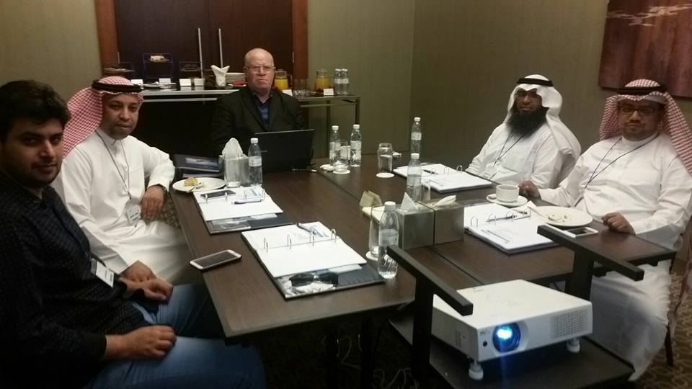

|  |  |
| --- | --- |
| **To join as an English Language Teacher** | **GOAL** |

**1, RSONAL INFORMATION :**

|  |  |  |
| --- | --- | --- |
| Ebrahim Mohammed Ahmed Asal  Bahraini  7/12/1951  511207492  Flat:12 Bldg. :1227 Road:4621Arad :246Bahrain  (973) 34353382  [tarjama@live.com](mailto:tarjama@live.com) |  | **Full Name :**  **Nationality:**  **Date of Birth:**  **C.P.R.**  **Address**  **Cell Phones**  **E-Mail** |

**2. EDUCATION QUALIFICATIONS**

|  |  |  |
| --- | --- | --- |
| 1975 | Zagazig University / Egypt | 1) Bachelor of Eng.& Education. |

|  |  |  |
| --- | --- | --- |
| 1977 | Zagazig University/ Egypt | 2) High Diploma in Education |

|  |  |  |
| --- | --- | --- |
| 1979 | American University in Cairo | 3) High Diploma in Translation. |

|  |  |  |
| --- | --- | --- |
| 1993 | University of Cambridge UK | 4) First Certificate in English |

|  |  |  |
| --- | --- | --- |
| 1995 | US Cultural Centre Bahrain | 5) iEARN Certificate in Teaching & training |

**3. COMPUTER & COMMUNICATION SKILLS**

* Good communication and organizational skills.
* ICDL Program at Ministry of Education in Bahrain .
* Flexible and innovative.
* Goal oriented, positive and supportive.
* Basics of IT
* MS-Window
* MS-Excel
* MS-PowerPoint
* MS-Word
* Internet &Hotmail
* Ability to integrate technology instructional approaches within professional development .

**4. CONSULTING & TRAINING COURSES ACCOMPLISHED:**

|  |  |
| --- | --- |
| **Teaching and Training Courses delivered** | **SN** |
| All English Curricula of Ministry of Education in Egypt and Bahrain | **01** |
| E-Learning and its impact on Bahrain Students 2013 | **02** |
| Strategies of Critical Schools 2013 | **03** |
| How to innovate Education Directorates 2013 | **04** |
| How to Carry out school Reform successfully. 2014 | **05** |
| The important Role of Student services Directorate 2010 | **06** |
| How to understand our pupils 2010 | **07** |
| Achieve your goals (for Teachers) 2014 | **08** |
| Successful School Principals 2016 | **09** |
| How can we make Teaching Satisfactory? 2015 | **10** |
| The way to manage performance dialogue 2015 | **11** |
| Successful Behavior Policy for Government Schools 2014 | **12** |
| Making Sense of Students Performance Data 2014 | **13** |
| Behavior for Learning strategy. 2016 | **14** |
| Objectives of Training programs. 2016 in Dubai | **15** |
| How to eliminate illiteracy in the Arab World .2016 | **16** |
| Differentiated Learning in Bahrain Schools .2011 | **17** |
| Problems of Class Problems in Secondary Schools .2011 | **18** |
| The role of Educational Leaderships to enhance Gifted Students | **19** |
| The successful ways to develop teaching Strategies in MOE.2013 | **20** |
| Education and Development in Bahrain 2015 | **21** |
| Criteria of Successful Teaching in government Schools .2017 | **22** |

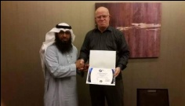

**5. CAREER IMPROVING STAFF PROGRAMS ACCOMPLISHED**

* [Assisting Teachers to acquire Self-Confidence](https://corporatetrainingmaterials.com/course/Assertiveness_And_Self-Confidence) in class
* [Communication Strategies](https://corporatetrainingmaterials.com/course/Communication_Strategies) in class
* [Creative Problem Solving](https://corporatetrainingmaterials.com/course/Creative_Problem_Solving) in class
* [Developing Creativity](https://corporatetrainingmaterials.com/course/Developing_Creativity) with our students
* [Interpersonal Skills](https://corporatetrainingmaterials.com/course/Interpersonal_Skills) in class
* [E-.Learning Essentials](https://corporatetrainingmaterials.com/course/mLearning_Essentials)
* [Time Management](https://corporatetrainingmaterials.com/course/Time_Management) in class .

**6. DEVELOPMENT COURSES DELIVERED**

* [Attention Management](https://corporatetrainingmaterials.com/course/Attention_Management) in class
* [Improving Self-Awareness](https://corporatetrainingmaterials.com/course/Improving_Self-Awareness) to our students
* [Increasing students Happiness](https://corporatetrainingmaterials.com/course/Increasing_Your_Happiness) during school day
* [Coaching Essentials](https://corporatetrainingmaterials.com/course/Life_Coaching_Essentials) for teachers
* [personal Learning](https://corporatetrainingmaterials.com/course/Social_Learning) in internet .

**7. COURSES FOR IMPROVING SCHOOL STAFF :**

* [Coaching And Mentoring](https://corporatetrainingmaterials.com/course/Coaching_And_Mentoring)
* [Developing New skills for supervisors and teachers](https://corporatetrainingmaterials.com/course/Developing_New_Managers)
* [Employee Motivation](https://corporatetrainingmaterials.com/course/Employee_Motivation)
* Differentiation in learning .How to let inattentive students learn
* [Facilitation developing Skills](https://corporatetrainingmaterials.com/course/Facilitation_Skills)
* [Leadership And Influence](https://corporatetrainingmaterials.com/course/Leadership_And_Influence)
* [Office Politics For Managers](https://corporatetrainingmaterials.com/course/Office_Politics_For_Managers) and school principals
* [Performance Management](https://corporatetrainingmaterials.com/course/Performance_Management) of school year successfully
* Essentials of [Supervising](https://corporatetrainingmaterials.com/course/Supervising_Others)
* [Virtual Team Building And Management](https://corporatetrainingmaterials.com/course/Virtual_Team_Building_And_Management)

**8. REFERENCES:**

|  |  |  |
| --- | --- | --- |
| **JOB & CONTACT DETAILS** | **NAME** | **N.** |
| **Director of Education Reformin Bahrain Schools.**  Economic Development Board. Manama – Bahrain  **Mobile : +973 36544633**  **Direct Fax : +973 17583330**  **E-mail** : [Geoff.hancock@bahrainedb.com](mailto:Geoff.hancock@bahrainedb.com) | **GEOFF**  **HANCOCK**  **(Head Consultant)**  **Improving schools Board - Bahrain** | **01** |
| **Consultant of Education Reform**  Economic Development Board . Manama – Bahrain  **Mobile : +973 36771250**  **Direct Fax : +973 17583330**  **E-mail** : [Adrian.wotton@bahrainedb.com](mailto:Adrian.wotton@bahrainedb.com) | **ADRIAN**  **WOTTON**  **(Consultant)**  **Improving school Board** | **02** |
| **Consultant of Education Reform .**  Economic Development Board . Manama – Bahrain  **Mobile : + 973 38379831**  **Direct Fax : +973 17583330**  **E-mail**: [christine.glen@bahrainedb.com](mailto:christine.glen@bahrainedb.com) | **CHRISTINE**  **GLEN**  **(Consultant)**  **Improving school Board** | **03** |
| **Principal Consultant of Education Reform .**  Economic Development Board . Manama – Bahrain  **Mobile : +973 36544733**  **Direct Fax : +973 17918726**  **E-mail** : [steven.resssig@bahrainedb.com](mailto:steven.resssig@bahrainedb.com) | **STEVEN**  **REISSIG**  **(Consultant)**  **Improving school Board** | **04** |
| **Secondary Education Principal**  **Mobile : (+973) 39683768** | **Jomaa Al Qallaf**  **Secondary Education Principal** | **05** |
| **Mahmood Latif : Marketing Manager**  **Mobile: (+966) 53000 1598**  [**latif@genceco.com**](mailto:latif@genceco.com) | **Royal Commission for Yanbu and Jubail , KSA** | **06** |